*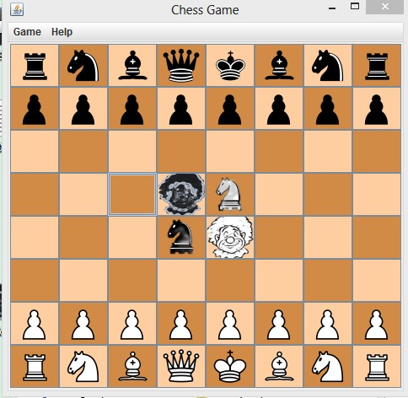***Chess Game Test Plan**

1. ***Game Window***

* When opening, make sure the program loads properly with no popup errors & warnings.
* The main game space is rendered in a **500 x 500** window.
* Program name is: “Chess Game”.

1. ***Chess Board***

* Make sure that the chess board is displayed with an **8x8** grid.
* Each square is a clicked button (but no follow up reaction).
* There’re **2 alternating colors**. So check that each square should have a different color with it’s up, down, left and right squares.

1. ***Default Chess Pieces***

* There are **2** different colors (black & white).
* Make sure currently, those pieces are placed in their default initial setup position.
* If given a non-default initial chess board setup configuration, make sure both black king & white king are on the board.

1. ***Two Custom Pieces***

* Black Chancellor, black clown, white chancellor and white clown are placed in the middle four squares.

1. ***Menu***

* Make sure the menu bar is displayed properly on the top of chess board.
* Currently, there’re two sub-menus called “Game” and “Help”. (Add more in Assignment1.2..?)